

**Computer Networks Lab 7**



**Name:Muhammad Shaheer.**

**Roll No:20p-0480**

NATIONAL UNIVERSTIY OF COMPUTER AND EMERGING SCIENCES, FAST- PESHAWAR CAMPUS Department of Computer Science & Software Engineering

Task 1:

How to configure an FTP server in Packet Tracer

Let’s now do FTP configuration in Packet Tracer:

1. Build the network topology.

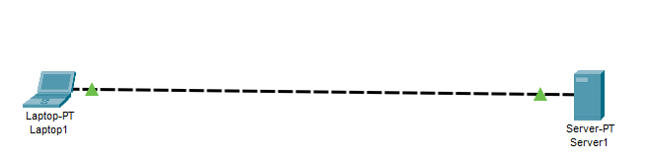

2. Configure static IP addresses on the Laptop and the server

Laptop: IP address: 192.168.1.1 Subnet Mask: 255.255.255.0

Server: IP address: 192.168.1.2 Subnet Mask: 255.255.255.0

3. Now try using an FTP client built in the Laptop to send files to an FTP server configured in

the Server.

From the Laptop’s command prompt, FTP the server using the server IP address by typing:

ftp 192.168.1.2

Provide the username(cisco) and password(cisco) [which are the defaults] for ftp login.

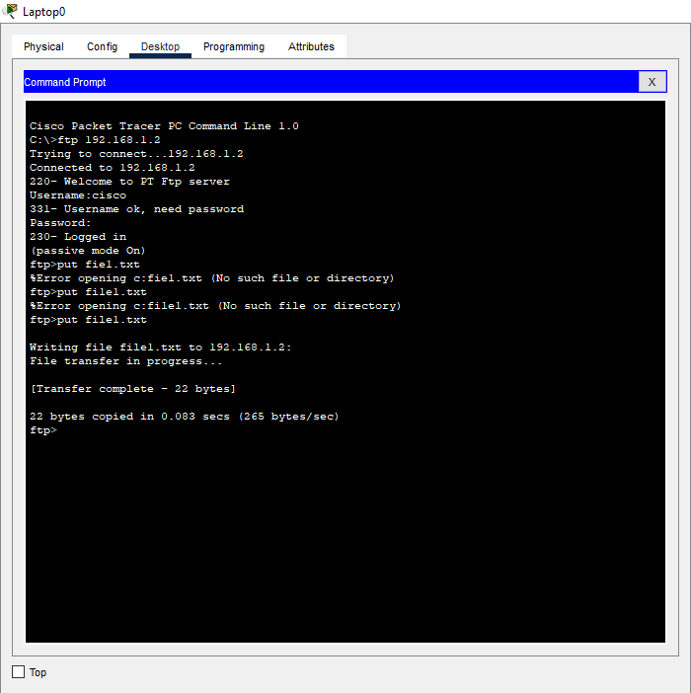

You are now in the FTP prompt .

PC0 has an FTP client which can be used to read, write, delete and rename files present in the

FTP server.

The FTP server can be used to read and write configuration files as well as IOS images.

Additionally, the FTP server also supports file operations

such rename, delete and listing directory.

With that in mind, we can do something extra. So let’s do this:

4. Create a file in the Laptop then upload it to the server using FTP.

To do this, open the Text Editor in the Laptop, create a file and give it your name of choice. Type

any text in the editor then save your file. e.g. myFile.txt.

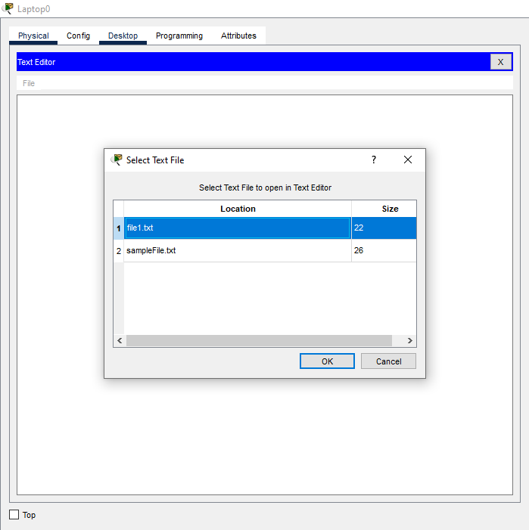

Now upload the file from the Laptop to the server using FTP. (An FTP connection has to be started first.

But this is what we’ve done in step 3)

So to do an FTP upload, we’ll type:

put myFile.txt

5. Go to the Server FTP directory to verify if the file sent has been received

Once file upload is successful, go to the Server FTP directory to verify if the file sent has been received.

To do this, go to Server-> Services->FTP. Here look for myFile.txt sent from the laptop.

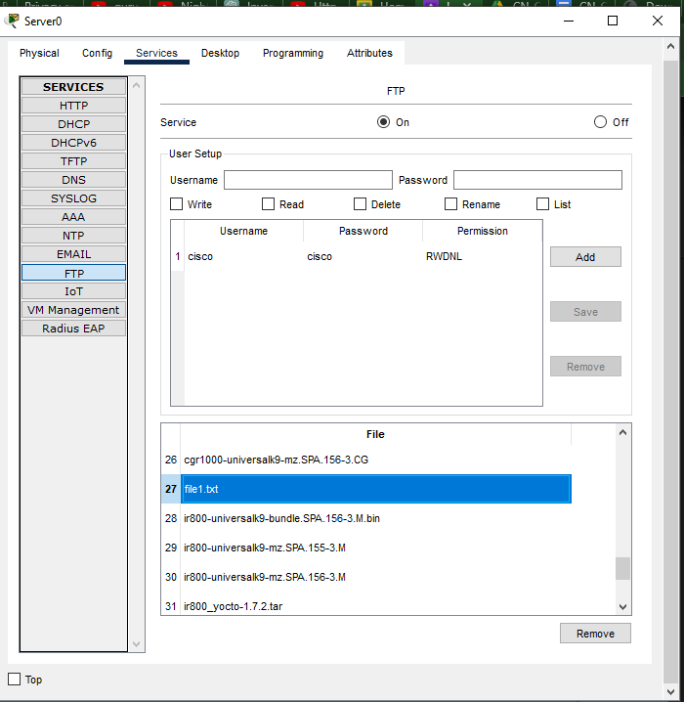

Task 2:

**Create and Upload html file to HTTP server directory Using FTP**

We’ll create an html file in our Laptop, upload it to HTTP server directory using FTP, then try

to access the file from the Laptop’s browser.

On the Laptop, open the text editor, then type some markup(html) and save the file with the

extension .html.

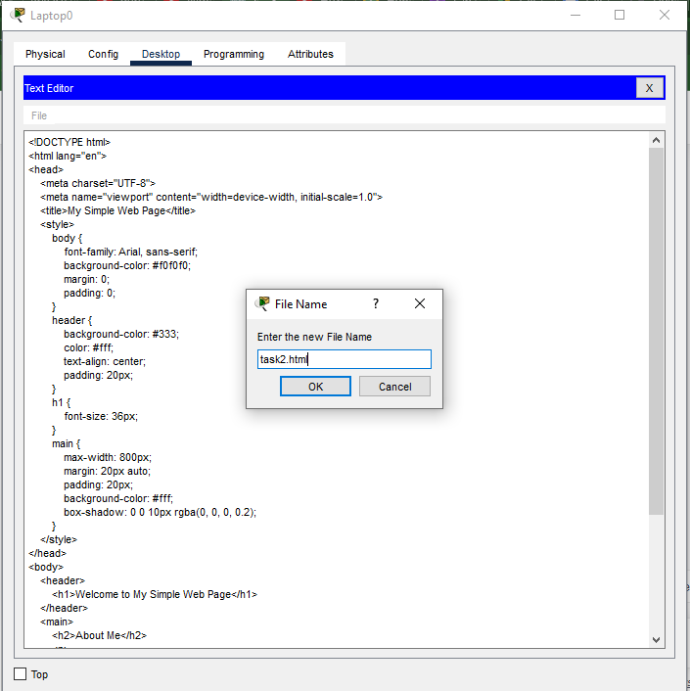

Save your file as an html file like this:

Now upload the file( flex.html) to the HTTP server using FTP. This is easy.

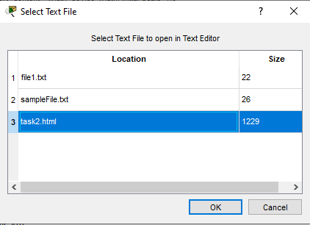

If you’re already in the HTTP directory, you just need to type: put task2.html.

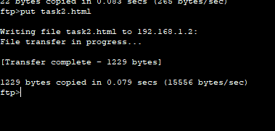

Check whether the html file uploaded has been received in the HTTP directory:

Go to Server->Services-> HTTP. Then look up for the file in the File Manager.

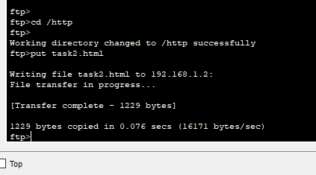

Now go Server

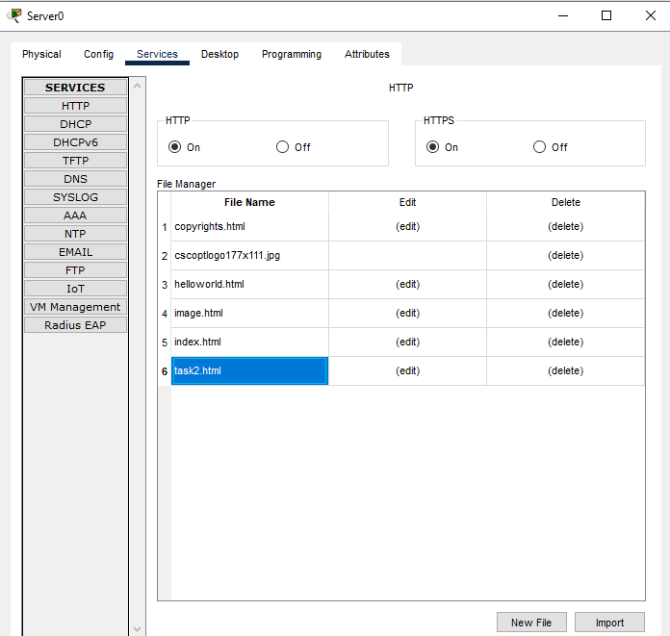

Now edit index.html file in the HTTP directory so as to include a link to task2 that we’ve just uploaded.

This will make file accessible from the Laptop’s browser. To do this, locate index.html then click edit.

Proceed to edit it as shown below. Then save and accept overwrite.

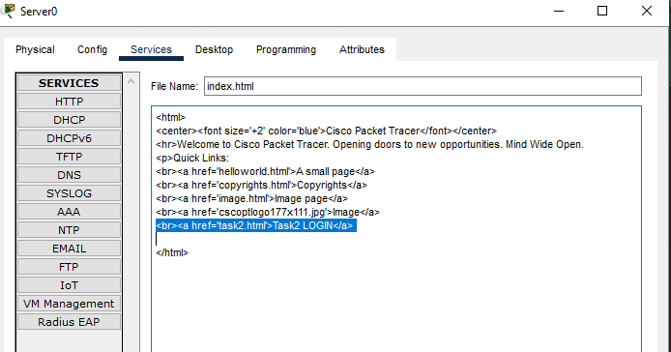

Finally, try to access the newly uploaded file from the Laptop’s browser.

So go to the Laptop’s browser and access the server using the server’s IP address. By doing this, the

browser is making an http request to the server. The server will respond to the Laptop with

the index.html file containing a link to task2 which we’ve uploaded from the Laptop using FTP.

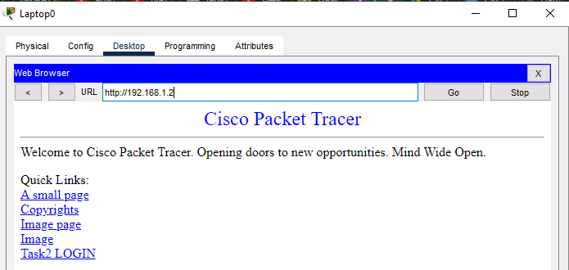

Click flex link to view the contents of the file in the browser.

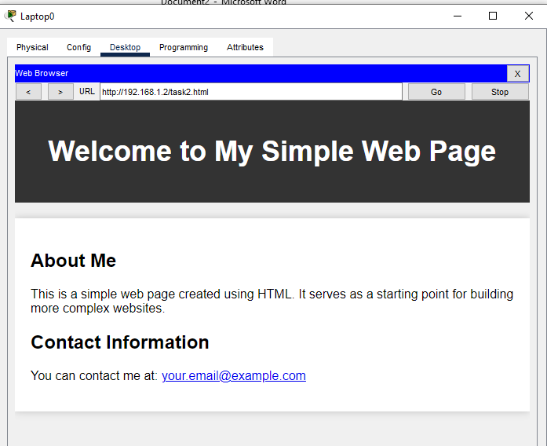

Task 3:

1. Configure an FTP server in Packet Tracer

2. Create and Upload html file to HTTP server directory Using FTP

3. Configure Mail server, Ftp Server, DHCP Server, DNS Server and web Server in a single

topology, use router and switch.

**Solution:**

Build Topology:

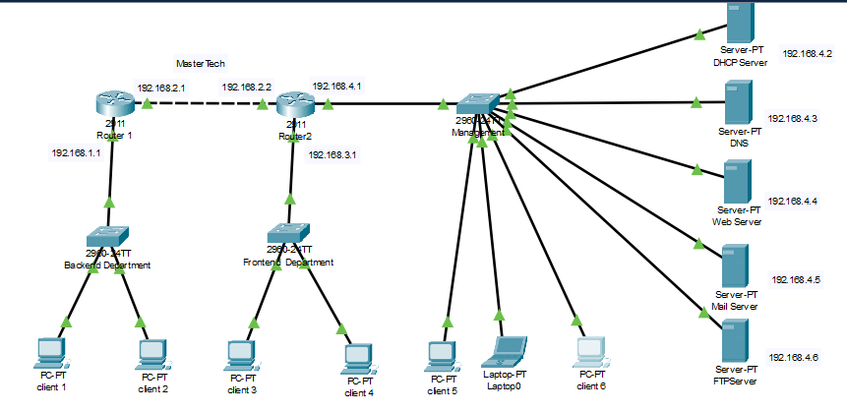

Now open command prompt on PCs and do FTP congigurations:

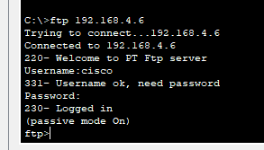

Now create a file

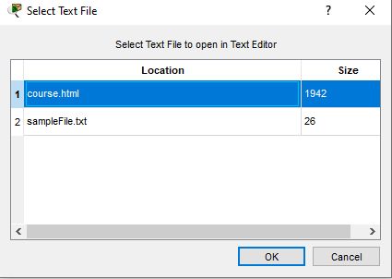

Now in command prompt change directory an put file

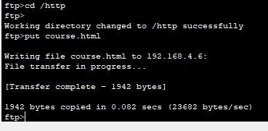

Now go to HTTP server and look for file:

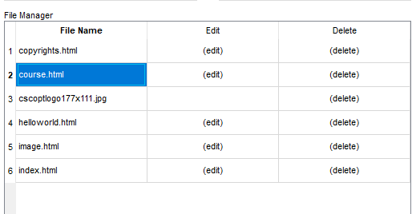

Now edit index.html file in the HTTP directory so as to include a link to coourse that we’ve just uploaded.

This will make file accessible from the pc’s browser. To do this, locate index.html then click edit.

Proceed to edit it as shown below. Then save and accept overwrite.

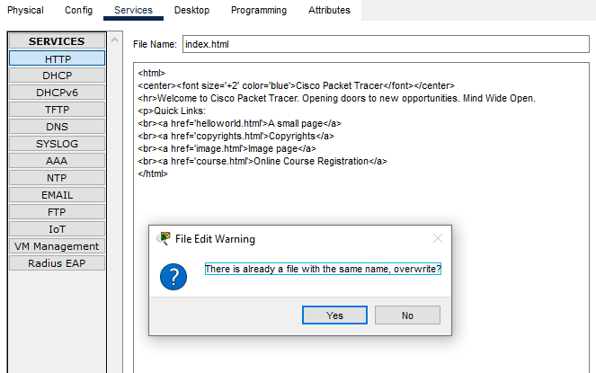

Now go to pc browser and access file

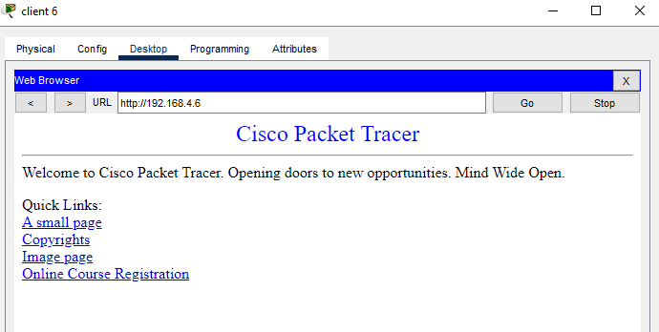

Open file:

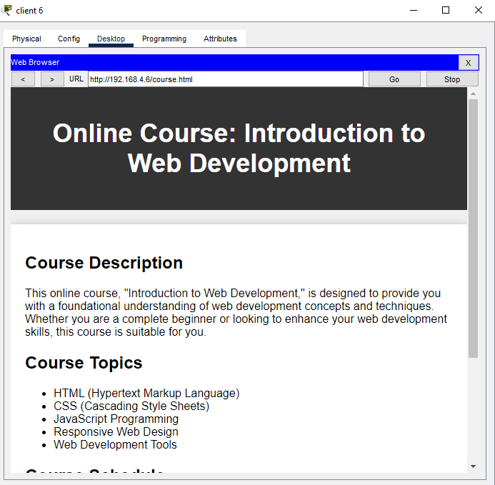

So its easily accessed everywhere.

So apply the same process on every pc and laptop connected in topology.